Construction of scanning laser phase shift range-finder on the basis of BOSCH DLE50

Table of Contents

Motivation 3
Introduction 5
Hardware structure 8
Firmware structure 11
General functionality 11
Measurement methodology 11
External interface of the MCU 16
Operating of frequencies synthesizer 16
Additional functionality 17
Specific of operation of the BOSCH DLE50 18
Connection and firmware replacemnt 19
The final results 24
Appendix 26
Long Commands 26
Short commands 33
Measurement results 34

Motivation
Nowadays amateur and hobbyist robotics engineering has reached such level that processing power of onboard computational units can considerably exceed processing power that is required to process signals from various onboard sensors, and therefore, it is possible to “load” the robot with additional information. On the other hand, increasing level of robots' autonomy requires more information about visual environment in order to make independent decisions and additional mobility. In other words, a problem of localization and spatial orientation tasks solution arises. Most popular methods that are used to solve these tasks are methods that are based on artificial vision (processing signal from video camera) and scanner systems based on range-finding sensors.
Processing of video signal is rather resource-consuming task in terms of computational costs and human hours for software development.
Such range-finding sensors as SHARO GP2Y0A21YK0F are widespread, although they are simple and cheap, but, nevertheless, their accuracy, non-linearity, working range and the size of the “spot” considerably restricts the area of their application.
Alternatively, there is possibility to use ready_to_use scanning laser range-finder such as SICK LMS-200, but their price starts with several thousands of euro, that makes them non-suitable for amateur engineering.
Alternatively, widely spread and rather cheap common-use laser range-finders can be adopted as scanning range-finders. Therefore, the main aim of the project is to develop range-finding sensor based on ready-made, widely spread and relatively cheap device. The main field of application – amateur robotics, construction of simple premises scanners, and solving localization tasks inside premises.
As a foundation most commonly spread common laser range-finders of BOSCH DLE50 was chosen, it is based on measuring the phase shift of reflected laser beam.
Luckily, widely spread and well known ATMEL’s microcontroller ATMegal 169P family is used in the chosen model of range-finder as a main controller. In this case, the main advantage of this family of controllers is that many developers of amateur electronics are already familiar with them and have corresponding development and debugging tools.
Taking into consideration the above stated, the laser range-finder BOSCH DLE50 adaptation task comes down to replacing its firmware with a self-made one. This work is dedicated to this task.
Original parameters of the BOSH DLE50:
Measurement method phase shift
Laser diode 635 nm, < 1 mW
Measurement range 0,05 - 50 m
Laser class 2
Measurement accuracy ± 1.5 mm
Measurement time, typical < 0.5 s
Measurement time, max. 4 s
Power supply 4 x 1.5 V LR03
Price 100Euro

Desired parameters of adapted device:
Distance - 0-10м
Accuracy - ±5-10мм
Measurement time - As fast as possible.

Introduction
The phase shift range measurement method is based on comparing phase of radiated signal with the phase of the signal that is reflected from the measured object. If the distribution speed is known and the difference of radiated and reflected signals' phases is known too, it is not difficult to find out the distance till the object. Such measurement method is widely used in radiolocation (radioaltimeter), geodesics, cartography and in many other fields.
Originally, such devices were based on radio waves, but with development of laser technology, and especially after development of cheap semiconductor laser, many such devices transferred to optical band.
Unlike radio phase range-finders, laser range-finders allow considerably narrow the measurement spot, and considerably simplify receiving and transmitting parts of the devices.
As the same question arises again and again, I will specially highlight, that devices that are reviewed in this work do NOT work on optical frequencies. Operating frequency of the device (laser modulation frequency) lies in the range of 350-500 MHz.
As it was stated above, the measurement principle is based on the phase difference between radiated and received signals, and on the speed of the signal's distribution. Let's review the most simple case that is shown below (Figure 1).
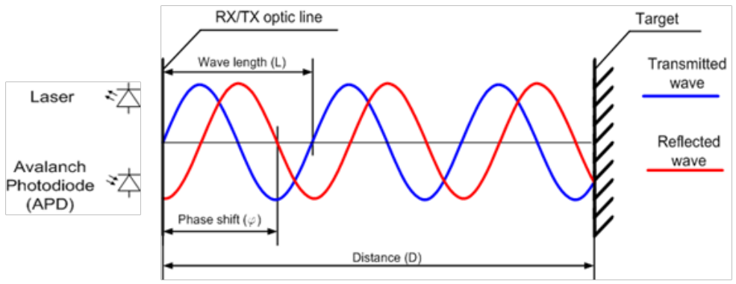
Figure 1. The principle of phase-shift distance measurement.
Transmitter radiates amplitude-modulated (AM) laser beam with modulating signal wave length L; at the distance D, the radiated signal is reflected and returns to the receiver with the phase f. If the wave length (L), number of full periods (N) and phase of incoming signal (f) are known, it is possible to calculate the distance till the target by using following formula:
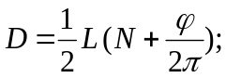
However, practically, in order to determine the number of full periods a priori knowledge of distance with certain accuracy or application of several oscillations with different wave length is required.
Let's assume that distance is less maximum device range and review the second option with application of several lengths of the waves. In this case enumerative or analytical method can be used.
When enumerative method is used, all possible N values for every wave length L are searched through. The search is conducted till picked distances for every wave length become equal.
There are rather many analytical methods, let's review the simplest one – the method that is based on beats of two proximate frequency oscillations.
If we review the phase difference of two sinusoidal oscillations that have close frequencies, the difference also will have sinusoidal rule and therefore this difference can be viewed as separate oscillation with its own wave length.
Moreover, the length of the wave of such oscillation will be the longer the less is the difference between frequencies of two initial oscillations.
Let's express it analytically by introducing following symbols:
– distance till the target;
– ½ of wave length;
– number of full periods;
– phase shift in rad/2Pi.

Let's suppose that there are two sinusoidal oscillations with the wave length 2L₀ and 2L₁, that are reflected from one object at the distance D, and that arrive at the receiver with phases f ₀ and f ₁.
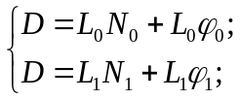 (1)
Let's assume that the number of full periods on measured distance is N₀ and N₁ and they are equal, therefore, we will indicate this number as N.
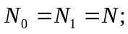 (2)
Then, let's solve the system (1) in respect of D.

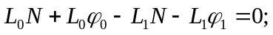 (3)
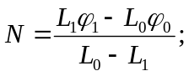 (4)
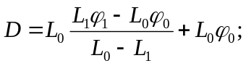 (5)
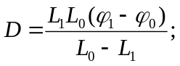 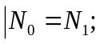 (6)

How it is shown in equation (6), the maximum distance where assumption (2) is valid can be found by replacing phase difference to the maximum possible value, i.e. 1.
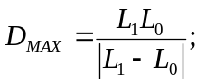 (7)
Therefore, by using two oscillations that have close frequencies it is possible to considerably increase the distance that allows non-uniqueness of separate measurements.
It is important to highlight that there are methods that do not apply sinusoidal signals, but employ a group of harmonics that on the receiving side is split into separate components using, for instance, Fourier transformation or other methods.
Practically, because of measurement errors and constrained bit grid (typical for 8 and 16 bits controllers) none of these methods alone is optimal. The most optimal are combinations of different methods. For example, initially, rough measurements are done using two frequencies (see expression 6). From obtained coarse result the number of full periods is determined for every separate frequency, and then separate distances are determined. If necessary they are corrected by +/- period (because of measurement errors the number of full periods could be determined wrongly too), and then, for example, they are averaged out.
In a particular device the wave length of separate oscillations and their number is determined considering accuracy, maximal operating distance, necessary speed of measurements, capabilities of transmit/receive equipment etc.
The device that is reviewed in the frame of this project (BOSCH DLE50) employs 15 different frequencies that are grouped into 4 groups with following values (MHz):
362.63, 364.25, 369.44, 371.06
398.00, 399.56, 402.13, 403.69
466.31, 467.94, 468.94, 470.63
482.06, 483.75, 485.31
This corresponds to the following device features (according to manual):
Measurement range 0,05 - 50 m
Measurement accuracy ± 1.5 mm
Measurement time, typical < 0.5 s
Measurement time, max. 4 s

Hardware structure
Generally, the structure of phase laser range-finding device can be presented in the following way (Figure 2):
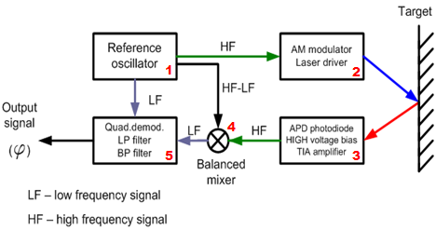
Figure 2. Structural scheme of laser phase range-finder.
There is main oscillator (1) that generates three types of frequencies. We shall name them in the following way: primary frequency (HF), secondary frequency (HF-LF) and intermediate frequency (LF). Ideally, the generator should be able to generate frequencies starting from specific phase and strictly synchronously.
The primary frequency (HF) is received by laser modulator (2) where laser beam is modulated according to amplitude and is radiated towards the target. The laser beam laser that is reflected from the target is received by receiving optics and then is sent to the photosensitive element (3). Usually, avalanche photodiode is used as a photosensitive element. Using the photodiode optical signal is transformed back into electrical signal of primary frequency (HF) and is amplified. Usually, current or so called transimpendance amplifier is used for that purpose.
Then, by using secondary frequency (HF-LF) the received signal is transferred to the low frequency domain, while the phase of received signal is maintained unchanged. Such transfer can be implemented, for example, by using balance mixer (4) or other known techniques.
As a result, at the output of the mixer there should be intermediate frequency (LF) signal with the phase shift as a function of the distance.
It is important to highlight that there are different approaches to frequency transfer methods. For example, there are devices where the signal is transferred to the intermediate frequency in optical band. In such devices, using semi transparent mirrors, part of radiated beam is forwarded towards photosensitive element where it is mixed with the signal that is reflected from the target.
Also, the transfer of the signal can be implemented before amplification as it is implemented in reviewed device (DLE50).
After the signal is transferred to the intermediate frequency, the phase difference between intermediate frequency from main oscillator and signal that is received at the output of the balance mixer is measured. Quadrature demodulator (5) or any other demodulator of angle modulation can be used as phase detector.
When initial phase of intermediate frequency from main oscillator is known with sufficient accuracy, then the distance computation can be done. Otherwise, initial phase shift is measured separately. In devices where transfer to intermediate frequency is done in optical band, outgoing beam or receiving optics are blocked while a initial phase shift measurement.
In the device considered in this project, the special mechanical shutter (or curtain) is used. In the shut position, the shutter simultaneously closes input optics and reflects out coming signal directly on photosensitive element.
Hardware scheme of the laser range-finder will be reviewed more detailed on the example of BOSCH DLE50 (Figure 3).
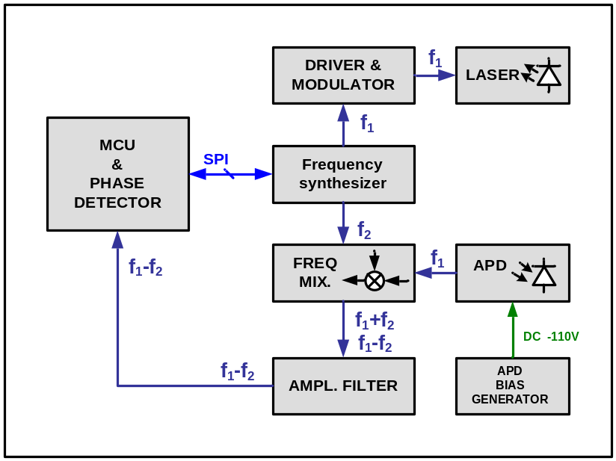
Figure 3. Structural scheme of phase shift laser range-finder BOSCH DLE50.
As it is shown on the image, the device consists of frequency synthesizer, modulator, signal mixer, amplifier -filter, high-voltage bias generator for avalanche photodiode and main control unit.
Frequency synthesizer.
It is operated by controller via SPI interface (MCU is SPI master). It is responsible for generating a set of operating frequencies, frequencies that are necessary to transfer the signal on operating frequency, performs the function of laser diode driver, and regulates bias voltage for avalanche photodiode.
Frequency mixer
It is built on discrete elements. For more detailed information see electric schemes.

Filter-amplifier
Consists of second order band-pass and low-pass filters that are build on operational amplifiers. Widely known Microchip IC MCP6002 (dual op amp) with single-supply operation from +1.8v till +5.5v and 1 MHz pass band is used as operational amplifiers. The frequency on the output of the amplifier is - 4.166kHz.
Driver-modulator
It is built on discrete elements, is managed by frequency synthesizer.
High voltage generator
It generates constant negative bias voltage for avalanche photodiode. It is operated by frequency synthesizer according to the values received from controller. Generator is built according to the DC-DC boostup converter scheme. The PWM signal which used in this converter is generated by MCU (period T = 30 microseconds, pulses width = 1.128 microseconds).
Main controller
Operates the process of measurement (switching of frequencies, switching on/off laser, etc.), calculates phase shift regarding inner reference signal, operates peripheral devices (keyboard, indicator, shutter), generates basic frequency for high-voltage generator. As a controller an ATMEL ATMegal169P with in-built LCD interface is used. The controller clock frequency is 8MHz.
As it was mentioned before, 15 different frequencies that are grouped into 4 groups are used for measurements.
f1 = [ 362.63, 364.25, 369.44, 371.06,
398.00, 399.56, 402.13, 403.69,
466.31, 467.94, 468.94, 470.63
482.06, 483.75, 485.31]
Intermediate frequency (f1-f2) is equal to 4.166kHz

Firmware structure

General functionality
Distance measurement can be done in two modes – independent (or stand alone) and controlled.
Independent mode – after pressing a button on keyboard, the device starts to continuously measure the distance untill the measurement process will be terminated by pressing stop button.
Controlled mode – the start and termination of distance measurement, as well as measurement parameters is controlled through external interface (UART). Additionally, there are several adjusting and diagnostics commands available through external interface. Diagnostics and adjustment commands include:
- switching on/switching of laser;
- opening/closing shutter;
- access to inner SPI bus of the device;
In both modes the acquired results are displayed on LCD display of the device and are sent to external interface.

Measurement methodology

Distance measurement methodology
It was already mentioned above that the original measurement procedure that is embedded by the manufacturer, consists of set of measurements on 15 different frequencies. In this project the main requirements such as measurement range and accuracy are decreased, while time of measurement is increased. In order to fulfill these requirements it was decided to considerably decrease the number of used frequencies. After several experiments following frequencies were chosen (Table 1):
Table 1. Frequencies that are used during distance measurement.
Frequency (MHz) | 1/2 of wave length L (mm)
486.2 | 308.5
482.6 | 310.8
470.8 | 318.6
466.7 | 321.4
403.9 | 371.4
Frequencies are chosen in order to compose 4 pairs with beat period in the range of ~10 meters (Table 2), and four pairs with the beat period of ~2 meters (Table 3).

Table 2. Frequency pairs that are used for rough distance estimation(+/- 0.5m).
L0 (mm) | L1 (mm) | Dmax_0 (м)
310.8 | 321.4 | 9.4
310.8 | 318.8 | 12.7
308.5 | 321.4 | 7.7
308.5 | 318.6 | 9.7
Table 3.Frequency pairs that are used for more precise distance estimation (+/- 0.1m).
L0 (mm) | L1 (mm) | Dmax_1 (м)
308.5 | 371.4 | 1.8
310.8 | 371.4 | 1.9
318.6 | 374.4 | 2.2
321.4 | 371.4 | 2.4

In order to measure the distance, it is necessary to measure the phase shift in respect of some reference. The special shutter is provided in the device. When closed, it is functioned as etalon distance and all subsequent measurements are done in reference to this shutter. In other words, in order to measure the distance till the object it is necessary to measure the phase shift between signal reflected from the shutter inside the device and signal that is reflected from the object.
Therefore, the measurement process consists of two stages – calibration and measurement. During the calibration process the phase shift of different frequencies' signals (see Table 1) that are reflected from the shutter are measured (reference or calibration phase shift), and during the measurement process the phase shift of the signal on the same frequencies, but reflected from the object (measurement phase shift). The difference between calibration and measured phase shifts is used for further computation of the distance till the object.
Practically, the measurement of calibration phase shifts can be done only once right after switching on the frequency synthesizer, additional (more frequent) calibration does not change the results considerably. However, in the original measurement procedure that is embedded by the device’s manufacturer calibration is done rather often in some cases. Apparently, there are some conditions that require to perform calibration more often.
As a result, 5 phase shift values for different frequencies are passed to distance calculation function as input arguments. Calculation is done in several steps. The first step is to roughly calculate distance by using formula (1) and frequency pair with large beat period (see Table 1).
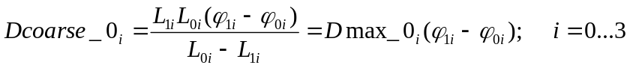 (1)
At this first stage, the maximally permissible measurement distance according to the above shown table (Table 1) is restricted with 8m.
At the second stage, measurement results are verified and dismissed if not trustworthy enough (not more than 2 results may be dismissed). The trustworthy parameter is a sum of the distances till all other results. Finally a decision about approximate (+/- 0.5m) distance till the object is made.
At the third and fourth stages the result is corrected according to the formula (2) with use of frequencies pairs from the table the least beat period (Table 3), results are verified and dismissed in the same way as at the 1st stage. Upon completion a decision about approximate distance till the object is made with accuracy +/-0.1m.
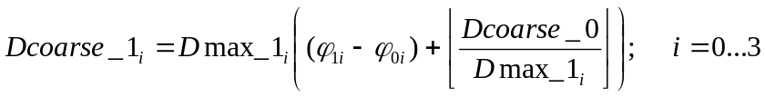 (2)
At last two stages, the received result is corrected according to the formula (3), but using the single frequencies (Table 1).
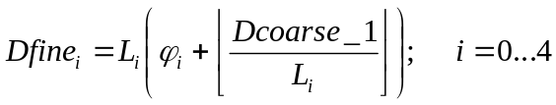 (3)
Received results are dismissed too and then averaged. The resulting measurement accuracy is about +/-5mm.

Phase measurement methodology
The method using quadrature heterodyne with quadruple sampling frequency is the simplest and most efficient method for signal phase measurement in terms of computational resources. In this case, generation of sine and cosine components is confluents to generation of zeros and sign alternating ones, while low-pass filters confluents to a simple interlacing.
sin → 0, 1, 0, -1, …
cos → 1, 0, -1, 0, …
The image below (Figure 4) shows classical scheme of phase demodulator using quadrature heterodyne oscillator.
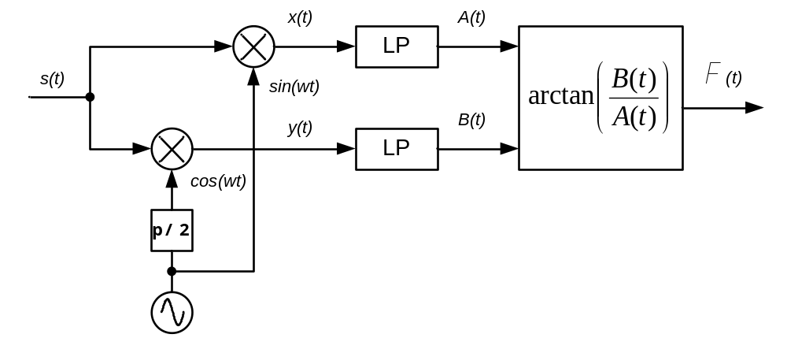
Figure 4. Block scheme of quadrature phase demodulator.
In case of sampling frequency is equal to quadruple carrier frequency, the scheme confluents in the following way (Figure 5):
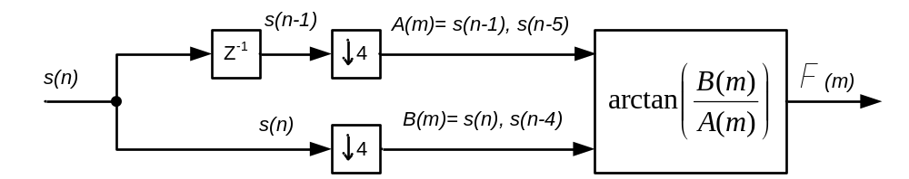
Figure 5. Confluent scheme of quadrature phase demodulator, when f0 = fs/4.
As intermediate frequency is 4.166kHz (period is 240 usec), the corresponding ADC sampling rate is set to 60 usec.
According to the scheme shown above (Figure 5), for every 4 samples of incoming signal there is one phase value. All phase values received during a single measurement can be, for example, averaged in order to obtain more accurate result. However, the arctangent calculation function is rather resource-consuming task and therefore it is more efficient to perform averaging before arctangent calculation. Additionally, all samples next but one are equal by modulus and differ by its sign. Thus, the following formula (4) can be used for averaging:
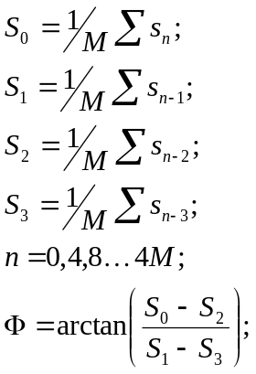 (4)
In order to calculate the arctangent the 3rd order polynomial approximation is used with so called self-normalization (Fixed-Point Atan2 With Self Normalization) see expression (5).
(5)
Thanks to http://www.dspguru.com

Measurement time
In original measurement procedure, every single frequency is generated during 4.8 msec which according to previously accepted sampling frequency equals to 80 samples of intermediate frequency. On intermediate frequency signal oscillogram transitional process is clearly seen after frequency alteration. Transitional process longs approximately 10 samples. In order to estimate phase of the signal it is more convenient to work with number of samples that are represented as power of 2. Moreover, the more samples there are in the measurement the more accurate will be the averaging. On the other hand, the less is the number of samples, the less time will be spent on measurement procedure.
After several expirements the following parameters were chosen as compromise:
Transition time – 16 samples (0.96msec)
Measurement time – 32 samples (1.92msec)
Therefore, minimal possible measurement time, excluding computational time, is (32+16)*60 = ~2.9 msec for one frequency. Therefore, the minimal possible full time of measurement procedure for 5 frequencies is 2.9*5 = 14.5msec. The computation and decision making time is estimated as 4 msec. Altogether, total distance measurement time is 18.5 msec.
Taking into consideration the above stated, the maximum possible measurement rate is set to 40 times per second (1 measurement per 25 msec).

External interface of the MCU
The UART interface with the following parameters was chosen as an external communication interface:
transmission speed - 76800
data format - 8N1
Incoming and outgoing data is transmitted as binary data packets. Incoming data is divided into two types – long commands and short commands.
Long commands – general service commands for diagnostics, testing and distance scanning purposes. Long commands contain command code, length and varying number of additional parameters. Number and format of parameters depends on the command itself.
Short commands – consist of two bytes and are used only during distance measurement. Short commands are used for managing APD bias voltage, measurement termination and calibration initiation. First four bits of a short command contain the code of the command, while the rest 12 bits contain parameter of the command. Parameter of the command is interpreted depending on its type.
Outgoing data – answers on long commands and measurement results.
In the “long commands” mode (the measurement is not conducted and controller is waiting for a long command), corresponding response is sent for every incoming command. Response consists of command code, response data length and data itself.
In the “short command” mode (during measurement) controller is continuously sending packets with measurements results. Every packet corresponds to single distance measurement and contains the following data:
- title;
- time label in 30 usec intervals;
- value of APD bias;
- distance in mm;
- error code;
- signal power (0…5), 0 for too low signal, 5 for overvoltage;
For more detailed information, please, see appendix “Measurements results”.

Operating of frequencies synthesizer
Operating of frequency synthesizer is done via bidirectional SPI interface. Synthesizer parameters are controlled by a set of 14 8-bits registers. Managing registers have addresses from 0,2,4…28.
In order to write a data in to the register(s), packet is transmitted by SPI bus (borders of the packet are determined by the #CS signal), where the first byte contains write starting address, and the rest of the bytes are data that will be consequently written starting from the given address.
In order to read registers’ content, a packet is sent via SPI bus where the first byte contains initial reading address and the 7th bit is set. The rest of the bytes should equal to 0. The number of bytes read is determined by the number of transmitted zero bytes. That is, on every transmitted zero byte the device answers with content of the consequent register.
SPI bus clock frequency = ½ of MCU clock frequency = 4MHz.

Additional functionality
Additionally to its direct tasks related with a distance measurement, the controller performs a set of additional tasks:
- Generates signal for voltage boost-up converter.
MCU continuously generates a sequence of impulses within a period of 30 usec and impulse width of 1.128 usec.

- LCD display rendering.
In-built LCD controller is used.

- Keyboard scanning

Specific of operation of the BOSCH DLE50
The main specific of measurement process is the fact that the accuracy greatly depends on the level of received signal, and the level of received signal, in turn, depends on reflecting surface. Most optimal surfaces are special light-reflecting films (such films that are used on road signs) or light-reflecting textile that are used for special and children's clothes. Then, in terms of reflecting power, follow red and white mat surfaces, such as painted wallpaper. Mostly unsuitable surfaces are black mat or glassy (lacquer), and surfaces with a complex reflection (multiple-layer semi-transparent structures). The level of the signal does not depend so much on the measurement distance as it depends on the type of reflecting surface.
As dynamic range of received signal is considerably higher than the dynamic range of used analogue-digital converter it is necessary to regulate the level of signal amplification in receiving part of the device. Amplification regulation is based on the change of constant voltage bias on avalanche photodiode (APD). The bigger bias voltage is applied to APD the bigger is its sensitivity, but also the level of noise in received signal is bigger. Experimentally, it was found that satisfactory measurement results are achieved when signal amplitude on ADC input starts from 150mV.
Another, unfortunately not fully researched feature is the change of APD sensitivity in time. For example, just after switching on the level of received signal can degrade by 3% per 20 seconds.
After five minutes after switching on the level of received signal can be twice lower than was received right after switching on. It was also noted that the level of the signal degrades the faster the bigger is the bias voltage applied to APD. APD sensitivity restores after removing bias voltage at approximately the same rate as it degrades.
Therefore, the task of APD sensitivity auto tuning algorithm comes down to maintenance of minimally sufficient signal level on ADC input. It was decided to maintain the level of incoming signal in the range of 135-350mV.

Connection and firmware replacemnt

In the following, as an example, device connection to the PC will be described more in details.
In that example the device will be connected to a PC using USB interface. As the USB interface provides +5V supply voltage too, the device will be powered from USB interface. Consequently, device’s battery compartment not used anymore and it might be used for USB<->UART converter allocation.
For beginning, the device should be disassembled as it is shown on the picture below (Figure 6).
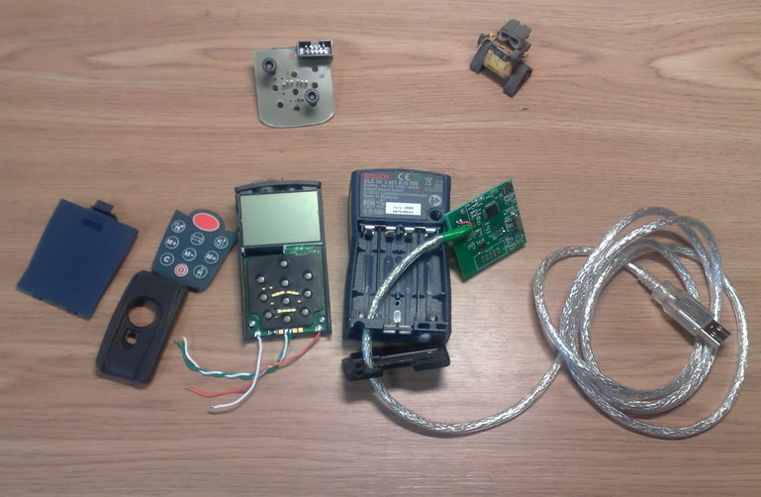
Figure 6. Disassembled device and wires connection.
The one of the batteries connecting plate should be removed and two holes are drilled on its place. The left hole for a USB cable, while the right one for UART and power supply wires.
UART interface’s wires are soldered to test pads and power supply wires are soldered to battery compartment connection. Also, one soldering bridge is required on the test pads. See picture above (Figure 7).
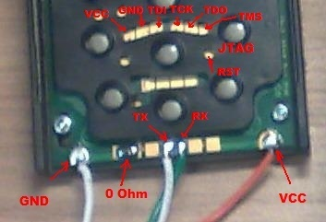
Figure 7. UART & JTAG wires connection.
After all wires are connected, the device should be inserted back to its enclosure and then connected to the UART<->USB converter as it shown on picture below (Figure 8).
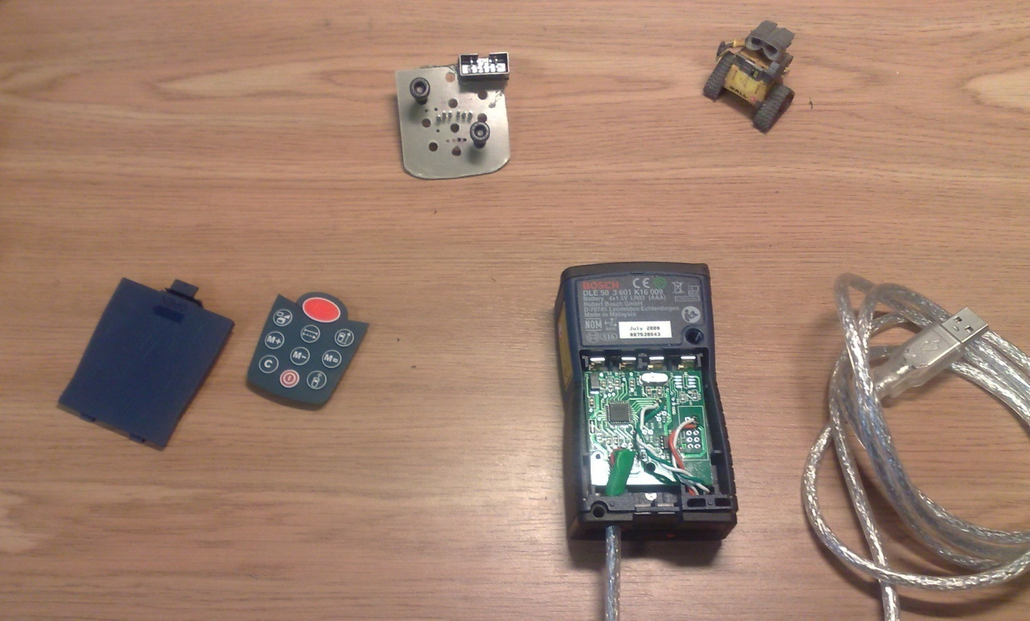
Figure 8. Connecting USB<->UART converter's board
Then, after all wires are connected, the device should be powered up and reprogrammed through JTAG interface. For that purposes I’ll use ATMEL’s JTAG debugger AVR AT JTAGICE mkII (Figure 9).
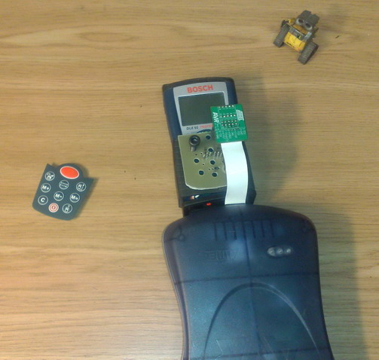
Figure 9. JTAG debugger connection.
Рисунок 9. Подключение AVR JTAGICE mkII
For more convenient JTAG connection the special adapter was built. This adapter just connecting device’s pads to standard 2 rows pin header (Figure 10).
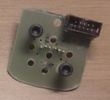
Figure 10. JTAG connector adapter.
Before firmware programming the device’s fuses must be set to following state (Figure 11):
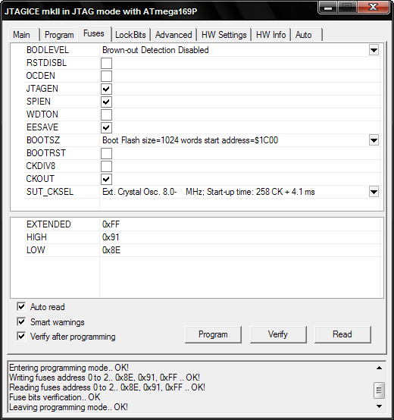
Figure 11. The device fuses.
After successful firmware programming and reboot the LCD screen should look like the following (Figure 12).
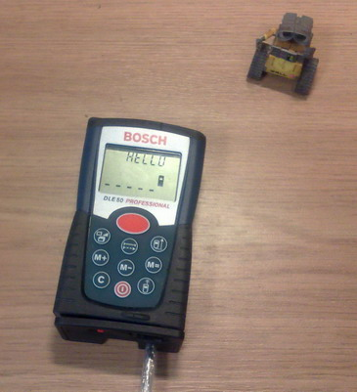
Figure 12. Initial state after power up.
Distance measurement process might be initiated either remotely (from external controller) or by pressing device’s button, the “big_red”.
During measurement, a distance till the target is shown in bottom part of the LCD screen, while APD bias is shown in upper part of the LCD (Figure 13).
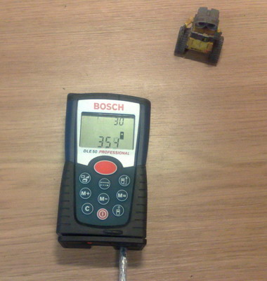
Figure 13. Measurement indication.

Final results
As a result a new firmware for microcontroller DLE50 was developed that allows perform continuous distance measurements.
The following parameters were achieved:
Measurement rate – 40 times per second (25ms).
Measurement range – 0.05…8m
Measurements accuracy – +/-5..10mm depending on conditions
Connection interface – TTL UART 76800 8N1
If necessary, measurements range can be considerably widened without apparent influence on measurements' time and accuracy. It is only question of computational complexity.
Additionally, there is a possibility to relocate the APD auto tuning algorithm outside controllers' borders, i.e. to the external controller. That is, the APD auto tuning management can be done through external interface.
Measurement start and termination can be done via DLE50 keyboard, or via external interface.
Measurement results are displayed on the LCD screen of the device, and in a more detailed way they are sent to the external interface.
In order to adapt laser range-finder for any projects it is necessary to have fully working laser range-finder DLE50 or DLE40. Then, it is necessary to reprogram controller’s firmware via JTAG interface, provide supply voltage +5V (batteries may be used as well), make one soldering bridge on the device test points and connect device’s UART interface to the external controller. And of course, it is necessary to write the control and results' processing programs on a external controller side.
In this project personal computer (PC) was used as an external controller. The range-finder is connected with PC through USB port and USB<->UART converter (FT232BM). The device is powered from USB port (see Figure 14).
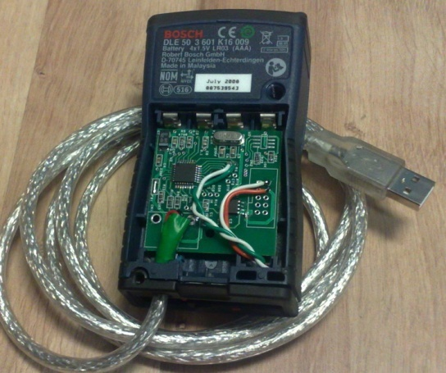
Figure 14. Example of range-finder connection to PC.
Accordingly, user interface, results' processing and recording programs were written as well.
This is it!

Appendix
The commands’ and the responses’ formats.

Long Commands
The long commands are dedicated for common purposes such as debugging, testing as well as for measurement initiation.
The long commands are available only while distance measurement is not active.

Signature (0x11)
Command
ADDR. | 0 | 1
FIELD | MARK (0xD5) | CMD (0x11)
Response
ADDR. | 0 | 1 | 2 | 3
FIELD | CMD (0x11) | LEN | MAJOR | MINOR

ADDR. | 4 | … | LEN+2
FIELD | NAME | … | 0

FIELD | DESCRIPTION
LEN | Length of response data
MAJOR | Major firmware version
MINOR | Minor firmware version
NAME | Firmware textual signature in null-terminated character string format

SPI_RAW_WRITE (0x15)
The command sends any raw data to the internal SPI bus and is used for operating of frequencies synthesizer (CF325).
Command
ADDR. | 0 | 1 | 2 | 3 | ... | LEN+2
FIELD | MARK (0xD5) | CMD (0x15) | CMD_LEN | WR_DATA_0 | … | WR_DATA_N
Response
ADDR. | 0 | 1 | 2 | ... | LEN+1
FIELD | CMD (0x15) | RESP_LEN | RD_DATA_0 | ... | RD_DATA_N

FIELD | DESCRIPTION
CMD_LEN | Length of data to be written.  min CMD_LEN = 0x01  max CMD_LEN = 0x0E
RESP_LEN | Length of data returned back. Normally, equal to the CMD_LEN.
WR_DATA_0 … WR_DATA_N | Data to be written in single SPI transaction. Number of data bytes must be specified in CMD_LEN.
RD_DATA_0 … RD_DATA_N | Feedback received during single SPI transaction. Number of data bytes is specified in RESP_LEN.

A typical sequence for synthesizer’s registers write is starting from address followed by registers’ data. For example, the command «0xD5, 0x15, 0x03, 0x04, 0x10, 0x012» will write value 0x10 into register at address 0x04 and value 0x12 at address 0x06 .

SPI_RAW_READ (0x16)
The command writes SPI read request sequence to the internal SPI bus, is used for synthesizer’s registers reading.
Command
ADDR. | 0 | 1 | 2 | 3
FIELD | MARK (0xD5) | CMD (0x16) | CMD_LEN(0x01) | REQ_LEN
Response
ADDR. | 0 | 1 | 2 | ... | LEN+2
FIELD | CMD (0x16) | RESP_LEN | RD_DATA_0 | ... | RD_DATA_N

FIELD | DESCRIPTION
REQ_LEN | Number of bytes to be read in single SPI transaction.
RESP_LEN | Length of data returned back. Normally, equal to the CMD_LEN+1
WR_DATA_0 … WR_DATA_N | Data to be written in single SPI transaction. Number of data bytes must be specified in CMD_LEN.
RD_DATA_0 … RD_DATA_N | Feedback received during single SPI transaction. Number of data bytes is specified in RESP_LEN.

In order to read synthesizer’s registers, the MCU should send to the internal SPI bus the following sequence 0x80, 0x00, 0x00 … 0x00, where number of bytes to be read is determined by number of zeros in the sequence. In response, the frequencies synthesizer will send values are stored in its registers.
For example, the following command
0xD5, 0x16, 0x01, 0x04
May return the following data:
0x16, 0x05, 0x3C, 0x23, 0xC4, 0x93, 0x04
where:
0x16 – response code;
0x05 – length of response;
0x3C – “garbage” remained since last SPI transaction;
0x23, 0xC4, 0x93, 0x04 – registers’ contents at addresses 0x00, 0x02, 0x04 and 0x06 accordingly.

CURTAIN (0x41)
The command open and close the device’s curtain (or shutter), which is typically is used during calibration process.
Command
ADDR. | 0 | 1 | 2 | 3
FIELD | MARK (0xD5) | CMD (0x41) | CMD_LEN(0x01) | ACTION
Response
ADDR. | 0 | 1 | 2
FIELD | CMD (0x41) | RESP_LEN (0x01) | STATE

FIELD | DESCRIPTION
ACTION | Action for the curtain driver  0 – open (curtain up)  1 – close (curtain down)  2 – toggle
STATE | Final curtain state  0 – closed  1 – opened

LASER_AIM (0x32)
The command turns on/off the laser for aiming, for instance.
Command
ADDR. | 0 | 1 | 2 | 3
FIELD | MARK (0xD5) | CMD (0x32) | CMD_LEN(0x01) | ACTION
Response
ADDR. | 0 | 1 | 2
FIELD | CMD (0x41) | RESP_LEN (0x01) | STATE

FIELD | DESCRIPTION
ACTION | Action for the laser driver  0 – laser off  1 – laser on  2 – toggle
STATE | Final laser state  0 – laser off  1 – laser on

SCAN_START (0x52)
Distance measurement initiation command.
Command
ADDR. | 0 | 1 | 2 | 3 | 4 | 5 | 6
FIELD | MARK (0xD5) | CMD (0x52) | CMD_LEN(0x04) | APD_CALIB |  | APD_MEAS
Response
ADDR. | 0 | 1
FIELD | CMD (0x52) | RESP_LEN (0x00)

FIELD | DESCRIPTION
APD_CALIB | Initial value for the APD high voltage bias generator registers used during calibration routine.
APD_MEAS | Initial value for the APD high voltage bias generator registers used during measurement routine.

Typical parameters:
APD_CALIB = 0x9010
APD_MEAS= 0x9030
In case of APD auto tune facility is enabled (by default), the specified values are used as initial values only. During a distance measurement or calibration, these parameters will be changed according to power of received signal.
After distance measurement is initiated, the device is switched to the “short command” mode and starts continuously send packet with measurement results. Accordingly, long commands are not valid any more until distance measurement is stopped.
Distance measurement is stopped by the short command STOP (0x0400). After that command, the device is switched back to the „long command” mode.

LCD (0x61)
LCD screen control command. The command is used to enable/disable special digits on the screen as well as for digits indication.
Command
ADDR. | 0 | 1 | 2
FIELD | MARK (0xD5) | CMD (0x61) | CMD_LEN(0x0E)

ADDR. | 3 | 4 |  | 5 | 6 | 7
FIELD |  |  | DIGITS_SET_0

ADDR. | 8 | 9 |  | 10 | 11 | 12
FIELD |  |  | DIGITS_SET_1

ADDR. | 13 | 14 |  | 15 | 16
FIELD |  |  | SIGN_MASK
Response
ADDR. | 0 | 1
FIELD | CMD (0x52) | RESP_LEN (0x00)

FIELD | DESCRIPTION
DIGITS_SET_0 | Set of digits and symbols in main digits set (bottom of the display). Digits are in BCD form. For other symbol coding see source codes.
DIGITS_SET_1 | Set of digits and symbols in auxiliary digits set (top of the display). Digits are in BCD form. For other symbol coding see source codes.
SIGN_MASK | The bit mask for all other signs on the display. Single bit per sign. Signs mapping see in source file.

Short commands

The short commands are valid only during a distance measurement and are used for altering APD bias value, initiation of calibration, distance measurement termination and switching the device back to “long command” mode.
Command
Byte 0 |  |  |  |  |  |  |  | Byte 1
7 | 6 | 5 | 4 | 3 | 2 | 1 | 0 | 7 | 6 | 5 | 4 | 3 | 2 | 1 | 0
APD_HI |  |  |  | CMD |  |  |  | APD_LO
APD_VALUE = (APD_HI << 12) | (APD_LO)

CMD | NAME | DESCRIPTION
0x01 | APD_MEAS | Set APD value used during measurement.
0x02 | APD_CALIB | Set APD value used during calibration.
0x03 | CALIBRATION | If APD_VALUE not zero, initiates calibration routine.  If APD_VALUE == 0, terminates calibration and switches device back to the measurement mode.
0x04 | STOP | Stops measurement and returns device back to long command mode.

Measurement results

The packed is sending on every single measurement during a distance measurement.
ADDR. | 0 | 1 | 2 | 3
FIELD | CMD | LEN (0x08) | TIME_STAMP

ADDR. | 4 | 5 | 6 | 7 | 8 | 9
FIELD | APD_VALUE |  | DISTANCE |  | ERR_CODE | PWR_RANGE

FIELD | DESCRIPTION
CMD | Current measurement state.  0x74 – calibration  0x73 – measurement
LEN | Packet length. Constant = 8.
TIME_STAMP | Timestamp in 30usec intervals
APD_VALUE | Value of APD control register used during this particular measurement.
DISTANCE | Measured distance till the target in mm.  Field is valid only if ERR_CODE == 0
ERR_CODE | 0 – ERR_OK. The result is valid.  1 – ERR_MAX0. Distance greater than maximum.  2 – ERR_AVG. Internal error.  3 – ERR_NOSIG. Either calibration or measure phase are not available yet.  4 – ERR_PWR. Too low or too high input signal.
PWR_RANGE | 0 – PWR_TOO_LOW. Signal level less than 100mV (discard the result)  1 – PWR_LOW. Signal level is between 100..135 mV  2 – PWR_OK. Signal level is between 135..350 mV  3 – PWR_HIGH. Signal level is between 350..600 mV  4 – PWR_TOOHIGH. Signal level is between 600..1300 mV  5 – PWR_OVERVOLTAGE. Signal level is greater than 1300 mV (discard the result).

